

***I am Anna.***

***I am a ballerina.***

***I am not a teacher.***

***I am seven. I am not five.***



***It is a radio.***

***It is not a TV.***

***It is blue.***

***It is not black.***

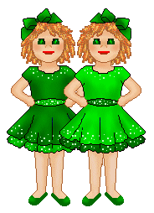

***They are twins.***

***They are sisters.***

***They are not brothers.***

***They are Kate and Jane.***

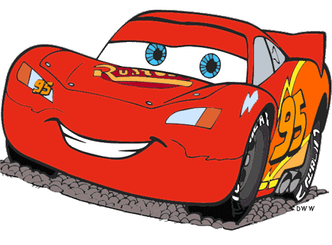

***It ____ a car.***

***It ____ _____ a plane.***

***It ____ red.***

***It ____ _____ black.***



***It ____ a cake.***

***It ____ _____ a lemon.***

***It ____ pink.***

***It ____ _____ blue.***



***He ____ a genie.***

***he ____ ____ a boy.***

***He ____ blue.***

***He ____ _____ red.***

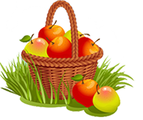

***They _____ apples.***

***They ____ _____ oranges.***

***They _____ red and yellow.***

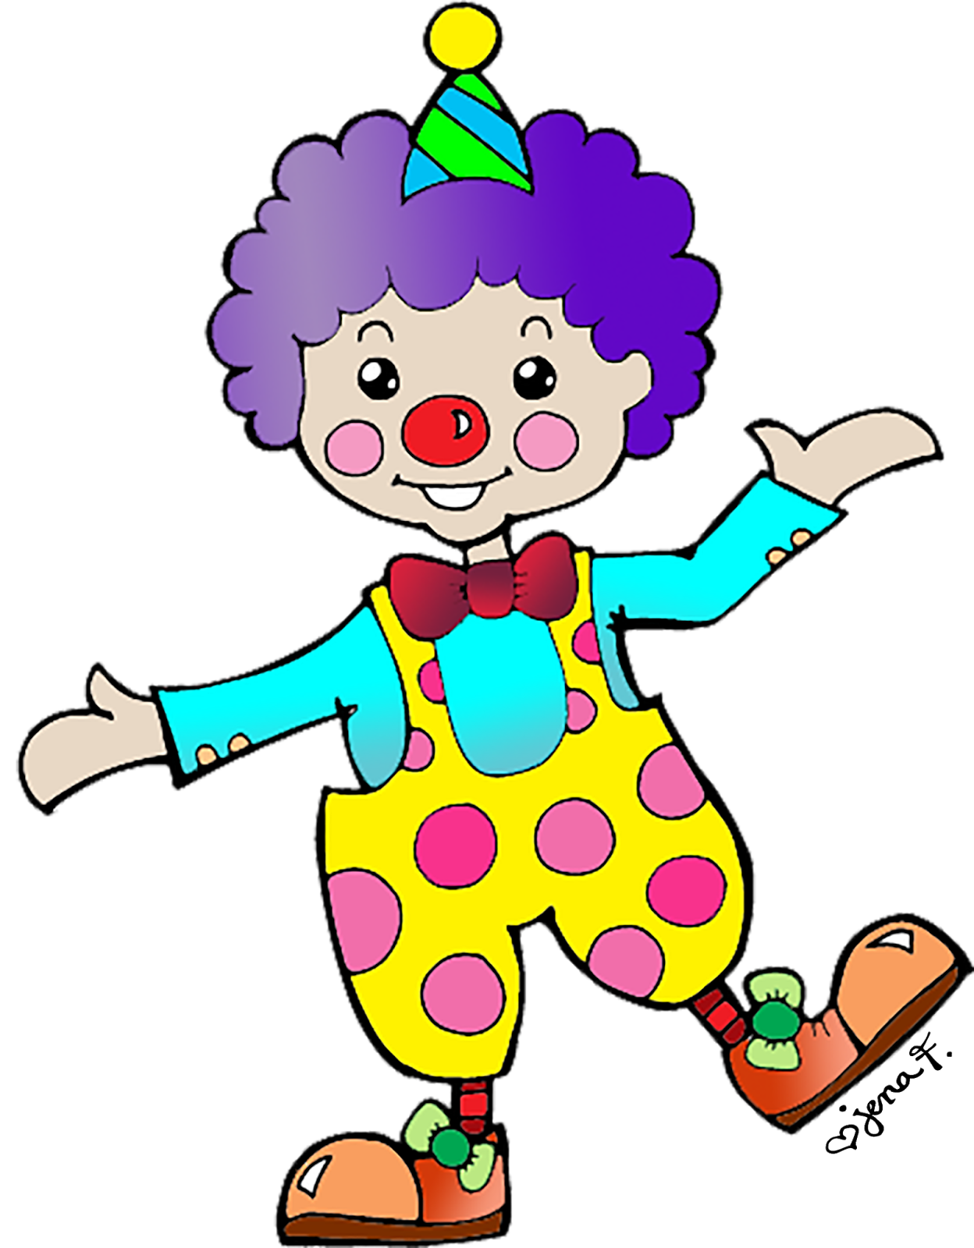

***He _____ Tom.***

***He _____ a clown.***

***He ____ _____ a genie.***

***He _____ ten. He _____ ______ eleven.***

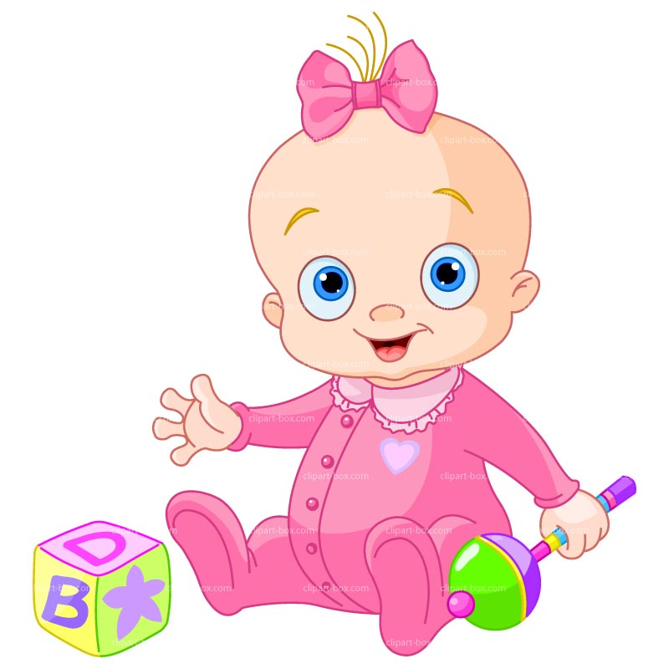

***She _____ Emma.***

***She _____ a baby.***

***She ____ _____ a doll.***

***She _____ one.***

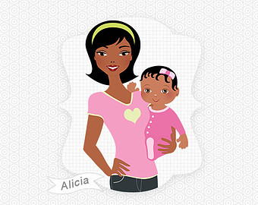

***She _____ Amelia.***

***She _____ a mother***

***She ____ _____ a father.***

***She _____ nice.***

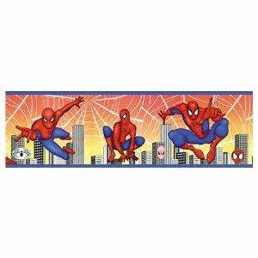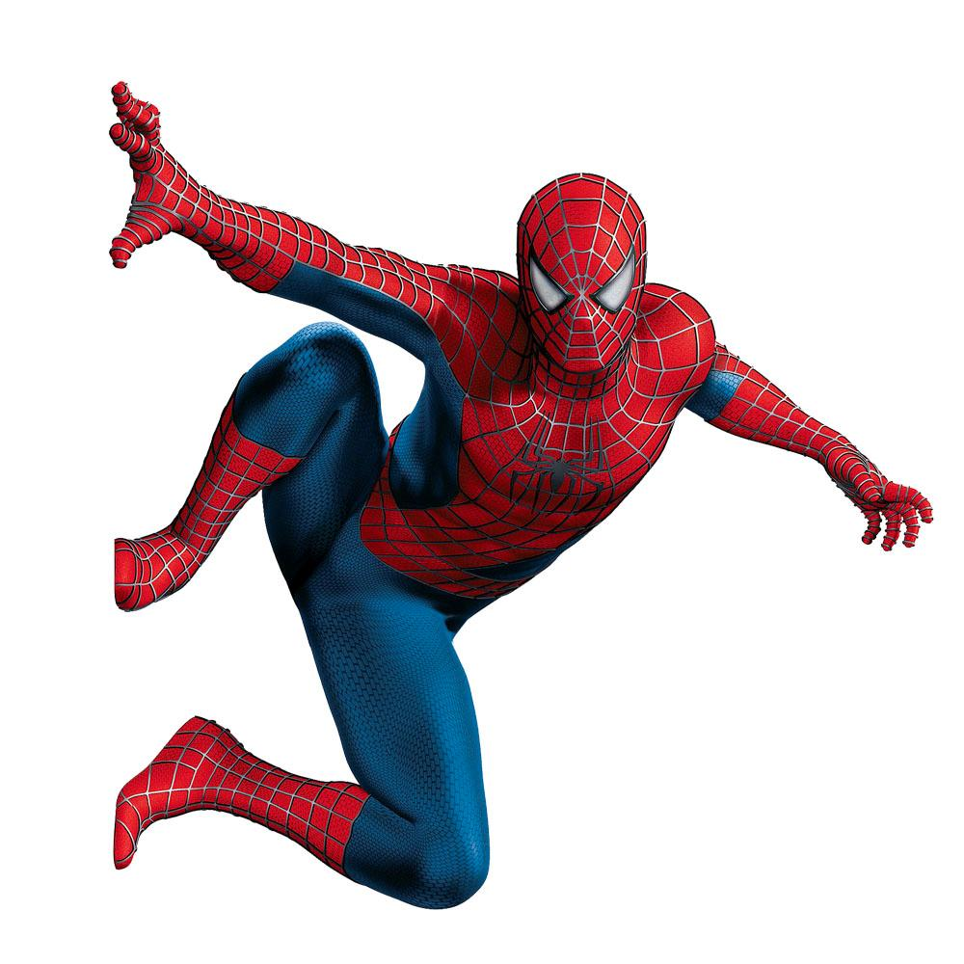

***Is he a Spiderman?***

***Yes, he is. He is a Spiderman.***

***Is he a doctor?***

***No, he is not. He is not a doctor.***

***She _____ one.***

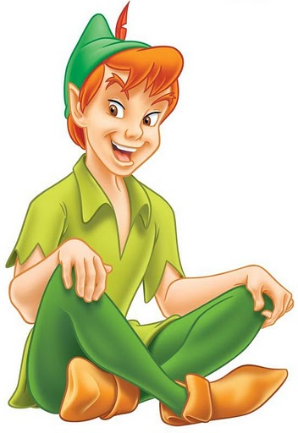

***Is he Peter Pen?***

***Yes, _____ ____. _____ _____ __________.***

***Is _____ Aladdin?***

***No, _____ _____ ______. He _____ not Aladdin.***

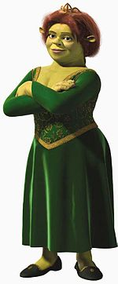

***Is she Fiona?***

***Yes, _____ ____. _____ _____ __________.***

***Is _____ Winx?***

***No, _____ _____ ______. She _____ not Winx.***

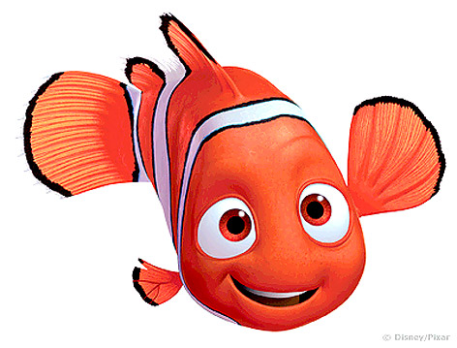

***Are they Nemo and Flounder?***

***Yes, _____ _____. They _____ __________ and Flounder.***

***_____ they Shrek and Donald?***

***No, _____ _____ ______. They _____ not _______ and Donald. They are fish.***

**8. Write a short story about your friend:**

**Name: Maria**

**Surname: Lopez**

**Age: 15**

**Job: student**

**Nationality: French**

**City: Paris**

**Hobby: drawing**

**1. Fill in the correct form of the verb to be:**

**1. They ____ friends.**

**2. Sam ____ at home now.**

**3. Lia and Kate ____ at school.**

**4. Tim ____ eleven years old.**

**5. Dani ____ a student.**

**6. You ____ at the English lesson.**

**7. They ____ from London.**

**8. I ____ in the park.**

**9. She ___ a doctor.**

**3. Correct the mistakes:**

**1. Lia are ill.**

**2. Benja am my best friend.**

**3. Loreto and Kate is sisters.**

**4. Tom and Bob is at home.**

**5. Dogs is animals.**

**6. Nick are from London.**

**7. Bill am eleven now.**

**8. They is very lazy.**

**9. We am in the hall.**

**2. Fill in am not, isn’t, aren’t:**

**1. He____ a pilot.**

**2. You ____ a boy.**

**3. She ____ a painter.**

**4. It ____ a cat.**

**5. I ____ at the lesson.**

**6. She ____ ten.**

**7. He ____ in the museum.**

**8. You ____ at school.**

**9. I ____ lazy.**

**5. Answer about yourself:**

**1. Are you a student?**

**2. Are you 18 years?**

**3. How old are you?**

**4. Are from Paris?**

**5. Are you from France?**

**6. What country are you from?**

**7. Are you a sportsman?**

**8. What is your home address?**

**9. What is your phone number?**

**6. Ask questions and give short form answers:**

**1. ___ he a doctor? Yes, he ___ .**

**2. ___ you in the classroom? No. we ____.**

**3. ___ they friends? Yes, they ____ .**

**4. ___ Liz at home? No, she _____ .**

**5. ___ you singers? Yes, we _____ .**

**6. ___ that Nick? No, he _____ .**

**7. ___ Bob from London? Yes, he _____ .**

**8. ___ you ten? Yes, I _____ .**

**9. ___ it a cat? Yes, it _____ .**

**7. Fill in am, is, are:**

**Hi! My name** ____ **Juan.**

**I ___ 10 years old. I ___**

**a student. I ___ a good boy.**

**I ___ a sportsman.**

**My best friends ___ Nick**

**and Charlie. They ___**

**students too. We ___ always**

**together. They ___ good**

**friends.**

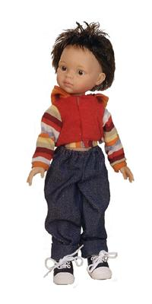

**Attention:**

**I**  **am**

**He**

**She**  **is**

**It**

**We**

**You** **are**

**They**

**4. Fill in the negative form of the verb to be:**

**1. They ______ students.**

**2. Sam _____ in the gym.**

**3. Kathy ______ twelve years old.**

**4. We ______ in London.**

**5. The dog _____ under the table.**

**6. I _____ in the museum.**

**7. You _____ twelve years old.**

**8. She _____ a dancer.**

**9. We _____ friends.**